**Page 1 Power BI - Question No. 1: Make at-least 5 questions and visualize the answers**

**a. Analysis objectives**

* To find out the number of employees for Job rotation
* To find out the achievement of a KPI target in Job involvement
* To find out the relationship between Job involvement and work life balance
* To find out the job roles to provide higher number of trainings this year
* To find out the department maximum staffing expense
* To find out the educational field that gives highest work life balance

**b. Analysis questions**

1. What is the number of employees who have worked under the same manager for the highest number of years?
2. Did we meet the target of 5 on KPI Job involvement?
3. Does higher job involvement lead to a lower work life balance among employees?
4. Which job roles received the lowest number of trainings last year?
5. Which department’s employees have the highest income and salary increments?
6. Which education field’s employees strike the highest work life balance?

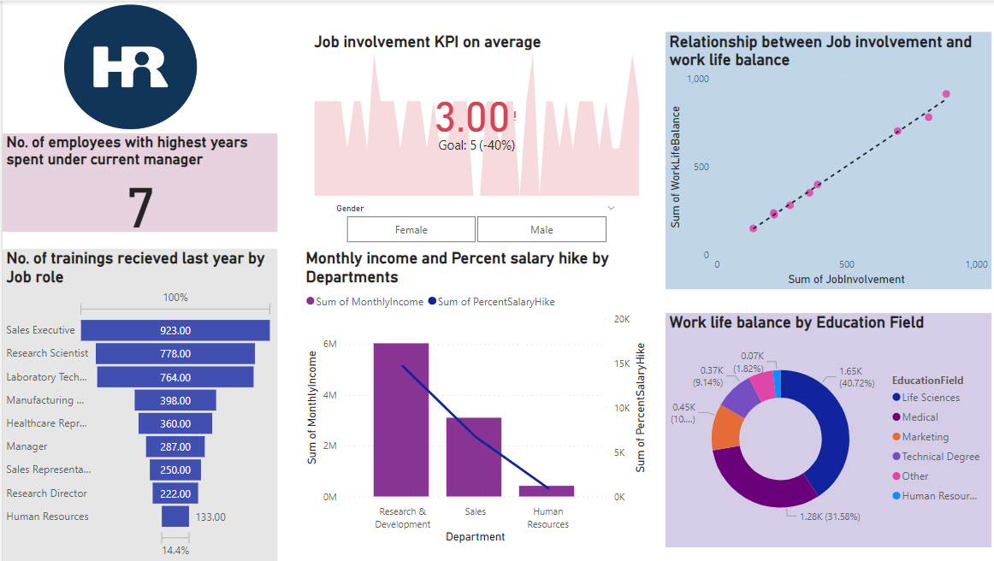

**Answers and Evidence based decisions:**

1. 7 is the number of employees who have worked under the same manager for the highest number of years. Therefore, job rotation under different mangers is needed for them.
2. We did not meet the KPI target of 5 on Job involvement. We missed it by 40%.
3. It’s ironical that higher job involvement actually doesn’t hinder the work life balance but improves it instead.
4. HR manager, Research director and Sales representative were the three job roles received the lowest number of trainings last year. This year, these job roles are to be provided with the highest number of trainings so that they do not become relatively incompetent.
5. Research and development department’s employees have the highest income and salary increments. This is the most cash draining department when it comes to staffing expense.
6. Life sciences is the education field from which employees strike the highest work life balance that too by a huge margin. Medical field is a close second.

**Page 2 Power BI - Question no. 2: Job level of employee (male, female and Percentage**

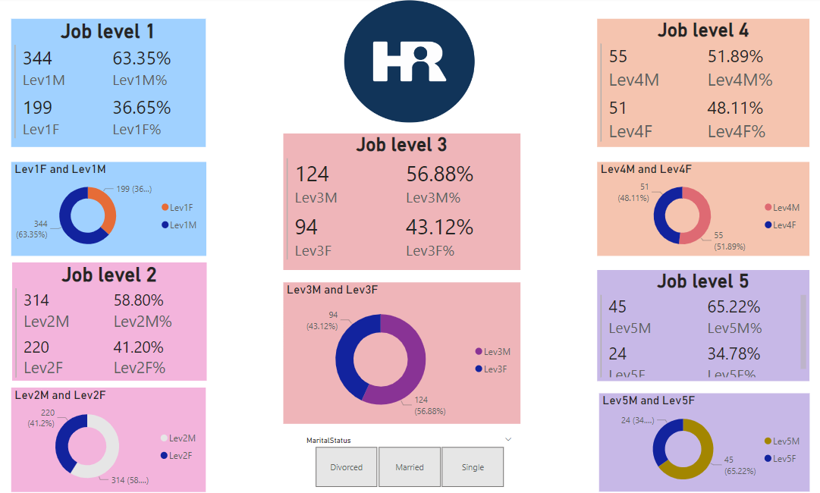

A dashboard is created to analyze the number of Male and female employees and their percentages in 5 different Job levels. For more clarity on the formulas used, Please refer to the DAX in the different measures created in the Power BI file itself. A slicer has also been added to slice or filter the data on the basis of marital status of the employees.

**Page 1 Power BI - Question number 3,4,5,6 COMBINED**

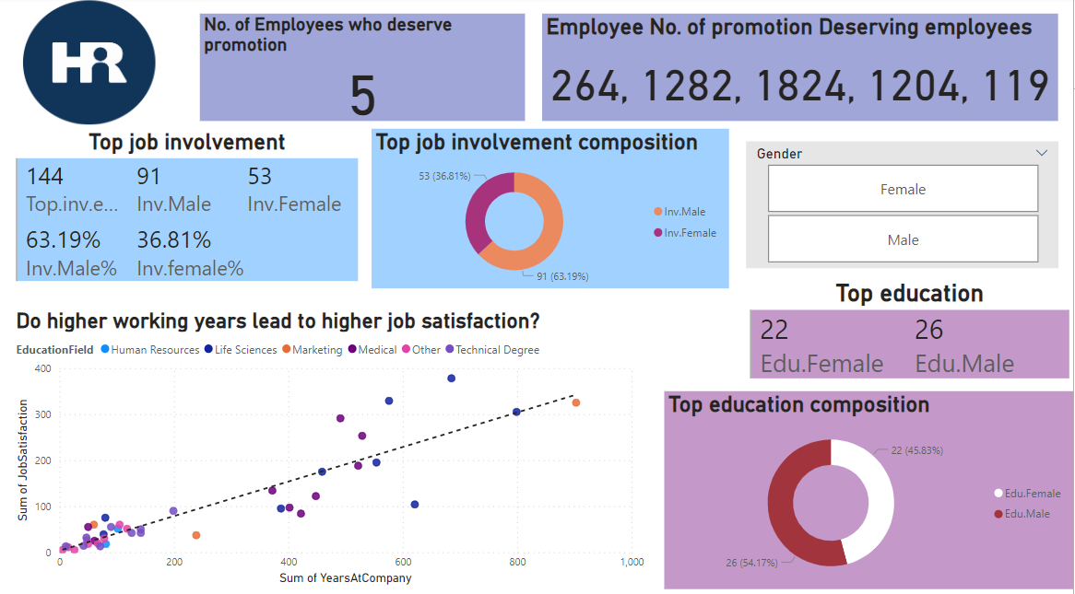

* 1. **Top job involvement ( male , female and percentage)**

Top job involvement for male, female and their respective percentages ha ve been calculated and a donut chart has been created to visually represent the count and percentages.

* 1. **Top education ( male , female)**

Top education for male and female employees have been calculated and a donut chart has been created to visually represent the count and percentages.

* 1. **Job Satisfaction ( higher working years-> higher satisfaction)**

To assess the job satisfaction, a scatter chart has been created to find out the relationship between no. of years worked **AT THE COMPANY** and Job satisfaction score. As there is no definite sign or a pattern in the scattered data points, **Job satisfaction is unrelated to the number of working years at the company**.

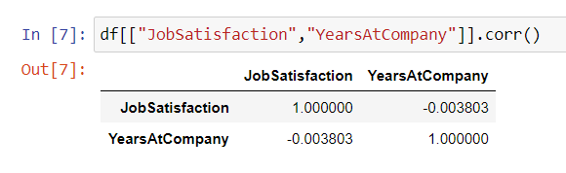

However, the same Pearson’s correlation **has been performed in Python** (**because Power BI doesn’t calculate correlation as a measure**). A Pearson’s correlation score of **-0.003803.** A correlation coefficient of -0.003803 indicates a very weak or almost no correlation between the two variables. The value of -0.003803 suggests that there is a slightly negative relationship between the two variables, but it is so small that it **is unlikely to be meaningful or practically significant**. Therefore, we can say that Job satisfaction and Years at company are not related to each other.

* 1. **Promotion Status**

Since there was not much instruction on the calculation of promotion status neither there is a specific column that I can refer to. **I used my own discretion** to calculate the number and specific employees who need to **be promoted on the basis of various criterion.**

* **Number of employees who deserve promotion**

I have written a DAX formula calculates the number of employees who are considered deserving of a promotion based on the following conditions:

* + - JobLevel: The employee's job level is greater than 3
    - PerformanceRating: The employee's performance rating is greater than 3
    - YearsSinceLastPromotion: The number of years since the employee's last promotion is greater than 10
    - YearsAtCompany: The number of years the employee has been with the company is greater than 10

The formula achieves **5 number of employees** to be promoted by filtering the 'HR Analytics Data (2)' table based on these conditions and counting the number of rows that meet all the criteria. The COUNTROWS function is used to count the number of rows in the filtered table.

* **Particular employee’s Employee numbers who need to be promoted**

I have written a DAX formula that first filters the 'HR Analytics Data (2)' table based on the above-mentioned conditions using the FILTER function. Then it uses the CONCATENATEX function to concatenate the filtered 'EmployeeNumber' values into a single string separated by commas and spaces.

The CALCULATE function is used to evaluate the expression in the current filter context, which is determined by the second argument of the function. In this case, the second argument is ALL('HR Analytics Data (2)'), which removes any filters on the 'HR Analytics Data (2)' table before evaluating the formula.

The result of this formula is the identification of Employees with the following employee numbers who need to be promoted:

* + - **264, 1282, 1824, 1204, 119**